Contents

Week 1 3

Supervised vs Unsupervised Learning 3

Supervised Learning 3

Unsupervised Learning 3

Regression Model 3

Linear Regression 3

Gradient Descent 4

Week 2 5

Multiple Linear Regression 5

Multiple Features 5

Vectorization 5

Gradient Descent 5

Practical Advice 6

Polynomial Regression 6

Week 3 7

Classification with Logistic Regression 7

Cost Function for Logistic Regression 7

Gradient Descent for Logistic Regression 8

Overfitting 8

Regularization 9

Week 4 10

Neural Networks 10

Neural Networks Model 10

Tensorflow 11

Week 5 12

Activation Functions 12

Multiclass Classification 12

Multi-label Classification 13

Additional Concepts 14

Week 6 15

Advice for applying machine learning 15

Bias and Variance 16

Development Process 18

Fairness, Bias, and Ethics 19

Skewed Datasets 19

Week 7 20

Decision Trees 20

Decision Tree Learning 20

Tree Ensembles 22

Week 8 24

Clustering 24

k-means Algorithm 24

Anomaly Detection 26

Week 9 29

Collaborative Filtering 29

Recommender Systems Implementation Details 30

Content-based Filtering 31

Week 10 34

Reinforcement Learning 34

State-Action Value Function 35

Continuous State Spaces 35

# Week 1

## Supervised vs Unsupervised Learning

### Supervised Learning

* Learn to predict input, output (or X to Y mapping) based on training on “right answers”.
* Types of supervised learning:
  + Regression
    - Predict numbers out of infinitely many possible numbers.
    - Example: predict house prices.
  + Classification:
    - Predict small number of possible outputs or categories/classes.
    - Can have more than 1 input value.
    - Akin to fitting a boundary line or segmenting data points.
    - Example: Breast cancer detection (is tumour malignant 1, malignant 2, or benign?).

### Unsupervised Learning

* Given learning data that is NOT associated with output labels.
* Algorithm’s job is to find some structure or patterns in the data.
* Types of unsupervised learning:
  + Clustering
    - Places unlabelled data into different clusters by similarity.
    - Example: Google News grouping related stories, grouping customers.
  + Anomaly Detection
    - Find unusual data points.
    - Example: Fraud detection in the financial industry.
  + Dimensionality Reduction
    - Compress data using fewer numbers while losing as little data as possible.

## Regression Model

### Linear Regression

* Fits a straight line through the data graph to read off input/output.
* Terminology
  + Training Set: data used to train model.
  + x: Notation to represent input.
    - Also called the “feature”.
  + y: Notation to represent output.
    - Also called “target”.
    - This is the actual output in the training set.
  + m: Number of training examples.
    - (x, y) represents a single training example.
    - (x(i), y(i)) represents the ith training example, where i is a specific row in the training set table.
  + y-hat: A prediction output by a function that was created using a learning algorithm with a training set, given an input x. y-hat is the function’s estimation of y (target).
  + 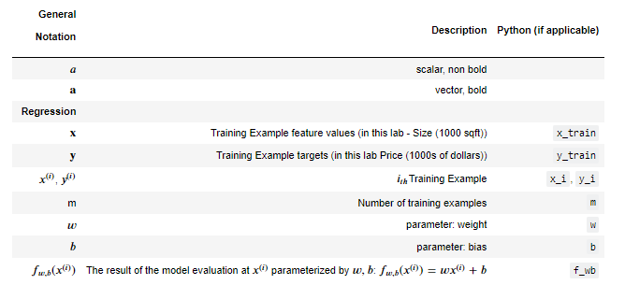
* Linear regression with a single variable (feature) is also called univariate linear regression.
* Cost Function
  + Compare y-hat with y, the difference is called the error.
  + Sum over all training examples, the error squared and average it by dividing by m.
  + By convention the sum is also divided by 2 to make further calculations easier (derivative term of gradient descent algorithm).
  + This is called the squared error cost function – this is the most popular for regression models.
  + Denoted by the variable “J” – we wish to minimize this.
  + 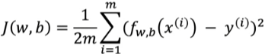
  + Visualizing the cost function in a 3D plot with w and b as the other 2 axes, the graph is shaped like a soup bowl.
  + In 2D, can represent J vs w vs b graph as a contour plot with minimum in centre.

### Gradient Descent

* Start with any initial values for the parameters w and b.
* Keep changing w and b until J settles at a minimum.
* 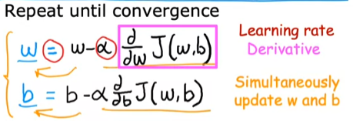
* May have more than 1 minimum in general (but only 1 for linear regression’s cost function).
* Can be used on more than just 2 parameters (w, b).
* Expanding out the derivative terms concretely (notice the 2’s cancels out for both terms):
* 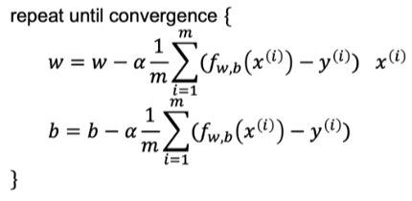
* Batch gradient descent: Each step of gradient descent uses all the training examples.

# Week 2

## Multiple Linear Regression

### Multiple Features

* xj denotes the jth feature in a training set.
* The number of features is n.
* **x**(i) now denotes a vector of features (the ith training example).
* x3(2) is the 3rd feature of the 2nd training example.
* Model can be rewritten in terms of vectors.
* 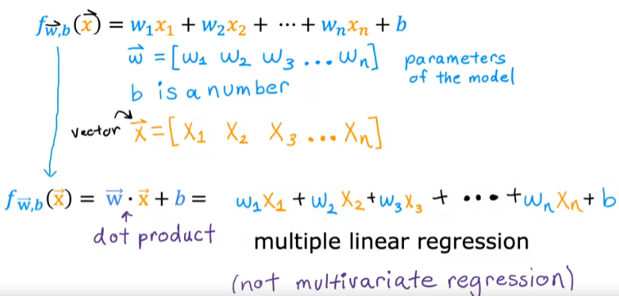

### Vectorization

* Speeds up dot product calculations compared to using a for-loop.
* Uses numpy’s dot() method which takes two vectors as an argument.
* Faster than for-loop because it uses parallel processing.
* Also applies to other linear algebra operations.

### Gradient Descent

* Comparison of single vs multiple feature algorithm (using vectorization for multiple features):
* 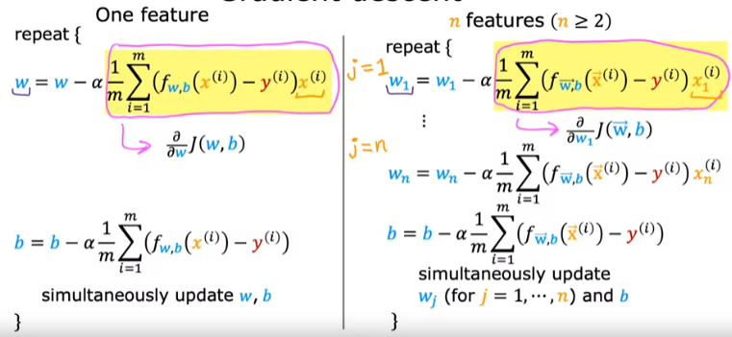
* Alternative to using gradient descent
  + Normal equation
    - Only applies to linear regression.
    - Solves for w, b without iterations.
    - Slow when number of features is large.
    - Gradient descent is still the preferred choice for normal practitioners.

### Practical Advice

* Speed up gradient descent
  + Feature scaling
    - Used when feature magnitudes differ greatly.
    - A large variation in feature magnitudes can cause gradient descent to “bounce around” and perform inefficiently.
    - Implementation:
      * Divide each feature by its maximum value.
      * Mean normalization: subtract from each feature value it’s mean and divide the difference by the feature’s range.
      * z-score normalization: Like mean normalization but divide by the feature’s standard deviation instead.
    - Aim for around -1 <= xj <= 1 for each feature, or within 1-digit numbers.
    - When in doubt, no harm to just apply it.
* Checking for gradient descent convergence
  + Plot cost function, J at each iteration of gradient descent.
    - The result is called the “learning curve”.
    - The vertical axis, J should be decreasing after every iteration.
  + Alternatively, use an automatic convergence test in code to check if J decreases by an amount less than a specific, predetermined epsilon value.
* Choice of learning rage
  + If J sometimes increases with each iteration, the learning rate may be too large.
  + Trade-off is that if learning rate is too small, gradient descent will take a long time to converge.
  + Values of alpha to try: …, 0.001, 0.003, 0.01, 0.03, 0.1, 0.3, 1, …
  + Then pick the largest possible learning rate which always causes J to decrease at every iteration.
* Feature engineering
  + Using intuition to design new features by transforming or combining original features.

### Polynomial Regression

* Uses the ideas of multiple linear regression and feature engineering to fit curves to data.
* Feature scaling becomes important if say you raise a current feature to a power i.e., width -> area or volume.

# Week 3

## Classification with Logistic Regression

* The output is a small set of finite values called “classes” or “categories”.
* The model is represented by the following equation:
* 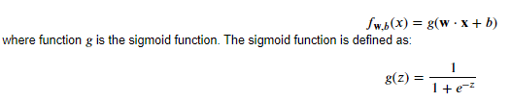
* Uses a sigmoid function to model the data – g(z) is equivalent to f_wb_i.
* 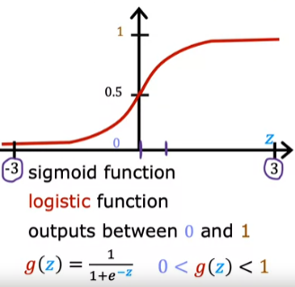
* g(z) defines the sigmoid function, where the input z (a scalar) is a prediction using an input and the model’s parameters.
* Logistic regression’s output can be interpreted as the probability that a class can be classified under a certain category.

## Cost Function for Logistic Regression

* The Loss function is an input to the Cost function and determines whether the graph of J is a convex function.
* 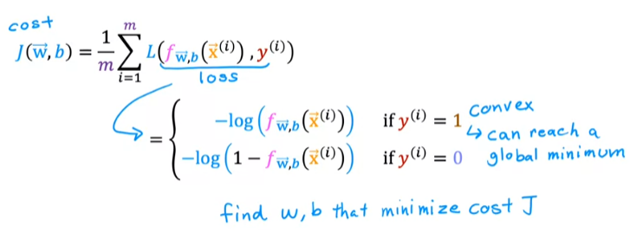
* Alternatively, in a single line, the Loss function can be written:
* 
* And the Cost function can be simplified to:
* 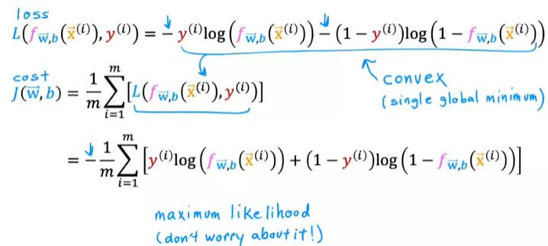
* The Loss function is calculated for each training example.
* The Cost function is obtained by summing the Loss function over all training examples and dividing by the number of training examples.
* The Loss function penalises models (by increasing greatly) if it gets the output wrong.

### Gradient Descent for Logistic Regression

* Like gradient descent for linear regression, but with a different Loss function and partial derivative.
* 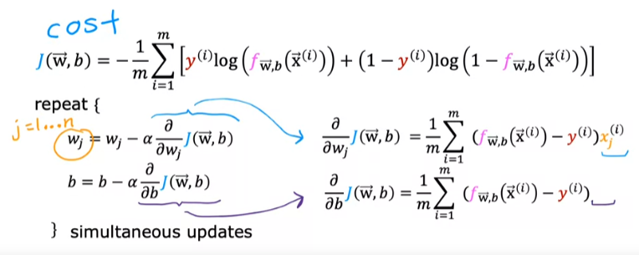
* Same concepts for:
  + Monitoring gradient descent (learning curve) for convergence.
  + Vectorized implementation.
  + Feature scaling.

## Overfitting

* If a model does not fit the training set well, we say that it is underfitting or have a high bias.
* Bias – the algorithm has underfit the data.
* The strong preconception that a model will fit the data despite data showing the contrary.
* If a model fits a training set well and performs well on data outside the training set, we call this generalization.
* If a model fits the training set extremely well, there is a danger that the model has overfit the data.
* Overfitting does not generalize well, and we can also say the model has high variance.
* Example for Linear Regression:
  + 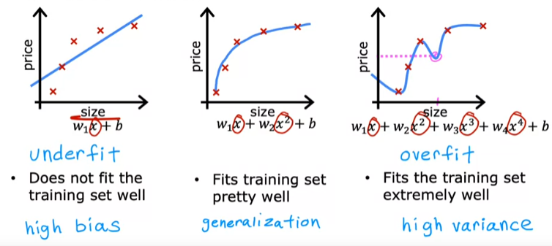
* Example for Classification:
  + 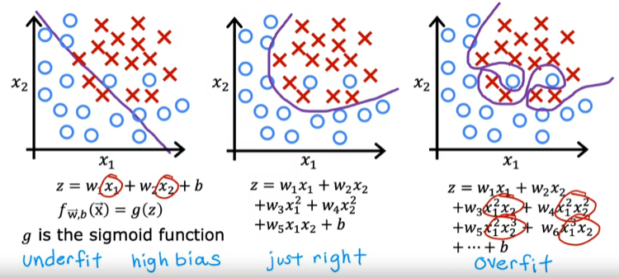
* Ways to address overfitting:
  + Collect more training examples.
  + Select features to include/exclude.
    - Many features with insufficient data can cause overfitting.
    - Feature selection: Use your intuition to pick the most impactful features.
    - The disadvantage of feature selection is that you lose some information.
  + Regularization.
    - Reduce the size of all parameters wj.
    - Allows you to keep all your features but prevents any feature from having too large an impact.

### Regularization

* We often have many features and may not know which feature to penalize (or reduce the size of).
* To solve this, simply add every single wj to the cost function.
* 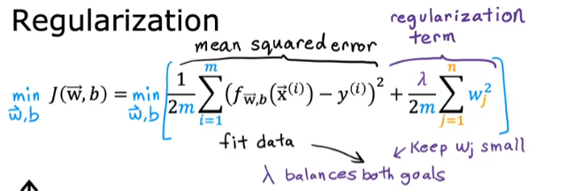
* This incentivizes the model to pick small values for wj.
* Choose a value of Lambda that minimizes both the contribution of the mean squared error and the regularization term.
* Regularized linear regression.
  + The difference is the Regularization term in the update for wj.
  + 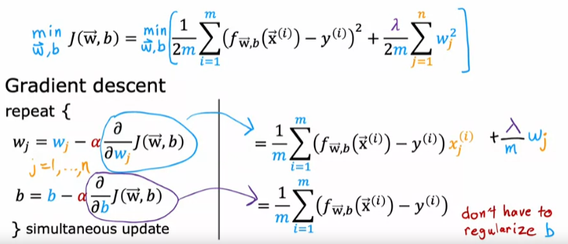
* Regularized logistic regression.
  + Like the cost function for normal logistic regression except with an additional Regularization parameter at the end.
  + 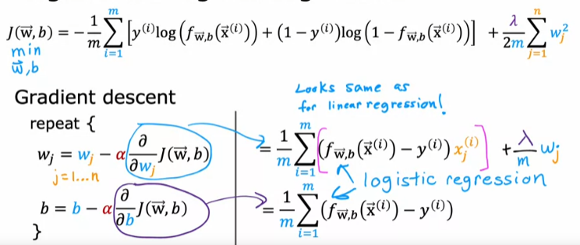

# Week 4

## Neural Networks

* Terminology used:
* 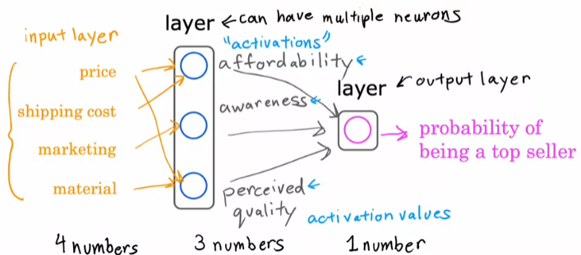
* The outputs from each neuron are called “activations”.
* Every neuron has access to all inputs and will learn to ignore irrelevant features.
* The intermediate layers are called the “hidden layers”.
* The input vector (Layer 0) is denoted by **x** and the intermediate output vector is denoted by **a**.
* Can think of this as logistic regression with the ability to feature engineer by itself.
* Can have multiple hidden layers as well.

### Neural Networks Model

* We say that **w**1[1], b1[1] are the parameters of neuron 1 in layer [1], and **a**[1] are the activation values output from layer [1].
* Each neuron is represented by a logistic regression model with parameters **w** and b.
* The input into a neuron is a vector.
* If predicting for a classification problem, an if-else can be applied to the final nth layer’s activation values a[n], say if a[n] >= 0.5 then output 1, else 0.
* When we say a neural network has 4 layers, we do not count the input layer, therefore there are 3 hidden layers and 1 output layer in this example.
* Terminology summary (with a zoom into Layer 3):
* 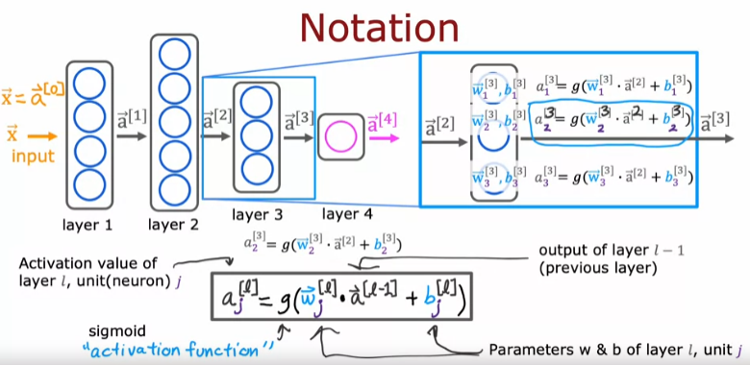
* When the calculations proceed from left to right of the page, we call this forward propagation.
* Back propagation is an algorithm that goes the opposite direction, used for learning.

### Tensorflow

* Overview of how to train a neural network in Tensorflow.
* 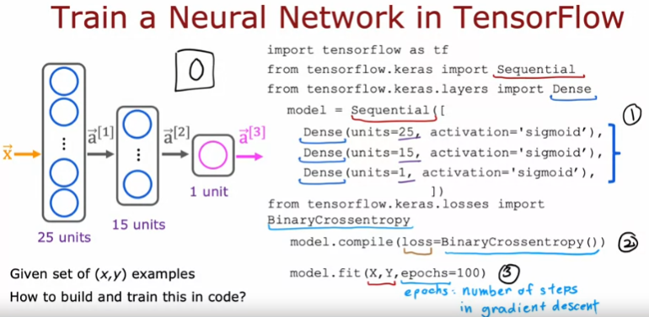
* Step 1 creates the model.
* Step 2 defines the loss and cost functions (Binary Cross Entropy is the same thing as the logistic loss function – for binary classification tasks, 2 classes).
* For a regression problem using mean squared error, you can use the argument loss=MeanSquaredError() instead (from tensorflow.keras.losses import MeanSquaredError).
* Step 3 computes derivatives for gradient descent using back propagation (epochs are the number of iterations).
* Using model.fit() updates the network parameters to reduce cost.

# Week 5

## Activation Functions

* Three of the most common activation functions:
* 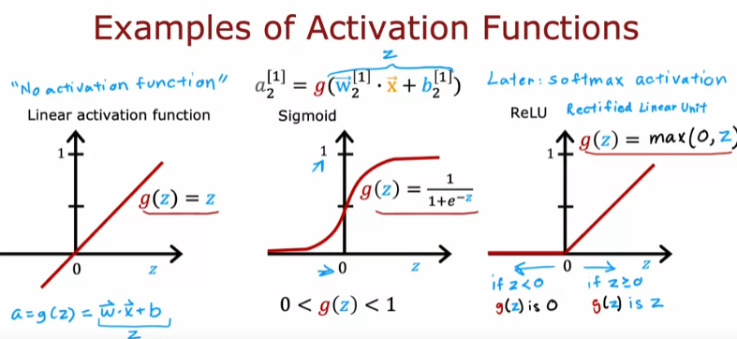
* ReLU can be good for when you want activation values that are natural numbers i.e., 0, 1, …
* How to choose an activation function.
  + Activation values of target/ground truth label, y.
    - Binary classification (0/1) – sigmoid (i.e. true or false)
    - Regression (can be positive or negative) – linear (i.e. stock prices can go up or down)
    - Nonnegative values – ReLU (i.e. house prices cannot be negative)
  + Hidden layers.
    - ReLU is the most common choice.
    - Faster to compute since it only needs to calculate the max() function.
    - Flat on only one part of the graph, so gradient descent is more efficient (faster learning).
  + 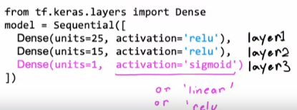
* Why do we need activation functions?
  + If we just use linear activation function, the entire network will essentially become linear regression, defeating the purpose of even using neural networks in the first place.
  + If all hidden layers use the linear activation function and the output is the sigmoid, we end up with logistic regression.
  + The takeaway: don’t use linear activation function in the hidden layer, just use ReLU.

## Multiclass Classification

* The Softmax algorithm is a generalization of logistic regression.
* Model for softmax regression:
* 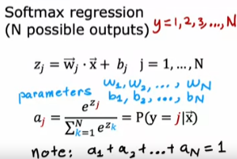
* Each ai value is dependent on z1 to zN – this is different to other activation functions which only depend on their own model.
* When n=2, it ends up reducing to logistic regression.
* Cost of softmax regression:
* 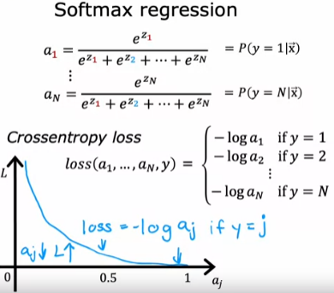
* Softmax is used in the output layer – if 10 categories, then use 10 units in this layer.
* Implementing MNIST with softmax (use the code highlighted in blue instead):
* 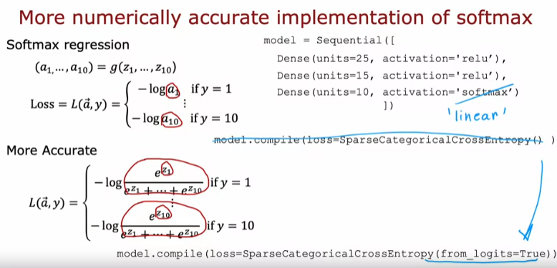
* With the more accurate version, we will need to add a couple of extra steps since the output is z rather than a.
* The code in full:
  + 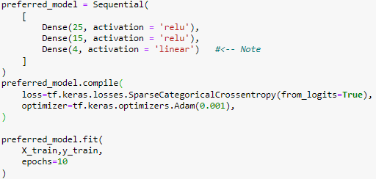
  + 
  + 
* Note the following difference in Loss function.
* 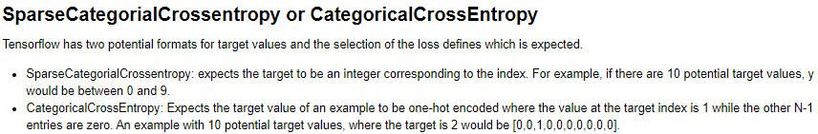

### Multi-label Classification

* Associated with a single input x, there are three different labels (i.e., in self-driving cars, does an image contain a car? Does it contain a bus? Does it contain a pedestrian?).
* Neural network can have more than one output (stored as a vector of outputs).
* It is also reasonable to make a few different multiclass classification models, each of single output as an alternative.

### Additional Concepts

* Alternative optimizations
  + Adam algorithm as an improvement to gradient descent.
    - Go faster – increase alpha (learning rate) if we are taking many little steps in the same direction.
    - Go slower – decrease alpha if we are bouncing around too much.
    - Adam: Adaptive Moment estimation.
    - Has as many alphas as parameters (w1, w2, …, b).
    - 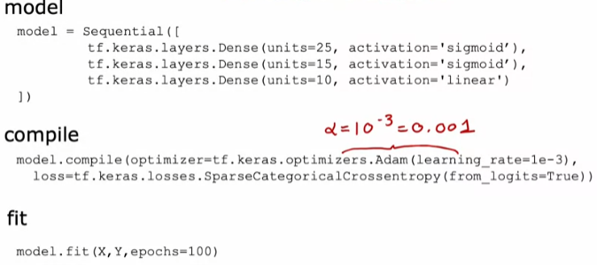
* Additional layer types
  + Dense layer: each neuron output is a function of ALL the activation outputs of the previous layer.
  + Convolutional layer: each neuron only looks at part of the previous layer’s inputs.
    - Why?
      * Speeds up computation.
      * Need less training data (less prone to overfitting).
      * Multiple convolutional layers in a neural network are called a convolutional neural network.

# Week 6

## Advice for applying machine learning

* Diagnostic: A test that you run to gain insight into what is/isn’t working with a learning algorithm.
* If you have a lot of errors, try:
  + Fixes High variance:
    - Get more examples.
    - Try smaller sets of features.
    - Try increasing lambda (regularization).
  + Fixes High bias:
    - Try getting additional features.
    - Try adding polynomial features.
    - Try decreasing lambda (regularization).
* Evaluating a model.
  + Split data into training set and test set (i.e., 70%, 30%).
  + Terminology:
    - mtrain: number of training examples.
    - Denote the training examples by: (x(1), y(1)), (x(2), y(2)), …, (x(m), y(m)).
    - mtest: number of test examples.
    - Denote the test examples by: (xtest(1), ytest(1)).
  + Train data (find parameters) using the training set and calculate the error using the test set.
  + 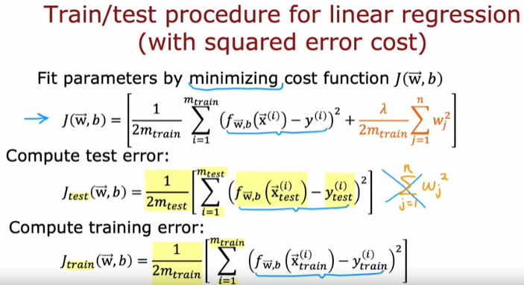
  + If Jtest is high, that is an indication that the model is not performing well.
* Model selection
  + Split data into three sets: Training (60%), Cross validation/Dev (20%), and Test (20%) sets.
  + 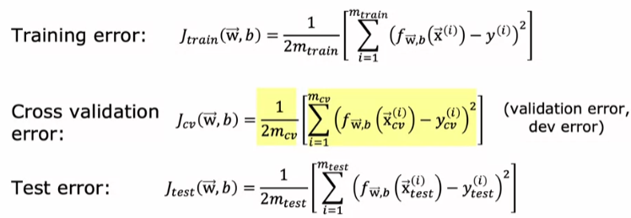
  + Pick model with the lowest cross validation error.
  + Report generalization error using the test set.
  + If you don’t use a cross validation set, your reported generalization error will be biased since we chose parameters which fit the test set.

## Bias and Variance

* Recall:
  + High bias: underfitting
  + High variance: overfitting
* When Jtrain and Jcv is high, this is usually an indicator of high bias.
* When Jtrain is low and Jcv is high, this is usually an indicator of high variance.
* If Jtrain is low and Jcv is also low, this usually indicates that the model is just right.
* Finding the right degree of polynomial is a balancing act:
* 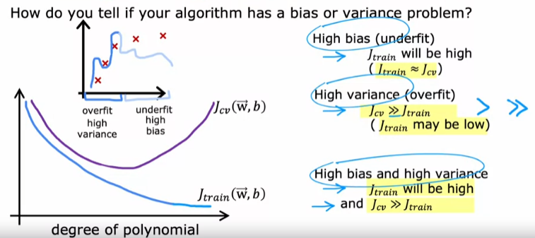
* Regularization
  + For linear regression:
    - If Lambda is large, w parameters are small and f(x) = b (a straight line).
    - This means Jtrain will be large.
    - If Lambda is small, no regularization so just fitting a high degree polynomial.
    - This means Jtrain is small and Jcv is large (high variance, overfitting).
    - An intermediate value for lambda gives a small Jtrain and Jcv.
  + To choose a Lambda value, use trial and error.
  + 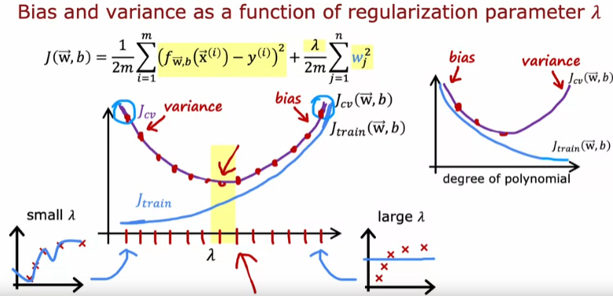
* Establishing a baseline level of performance – you can judge your algorithm according to the following:
  + Human level performance.
  + Competing algorithms performance.
  + Guess based on experience.
* 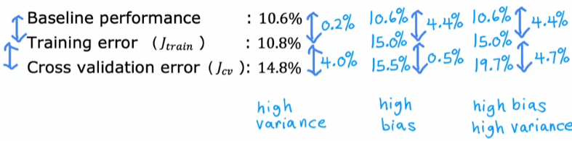
* Learning curves – plot your errors on y-axis, mtrain on x-axis.
  + 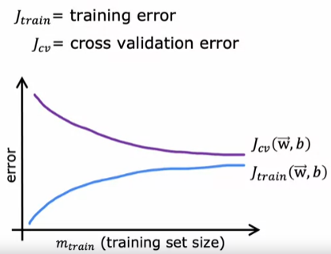
  + For high bias:
    - 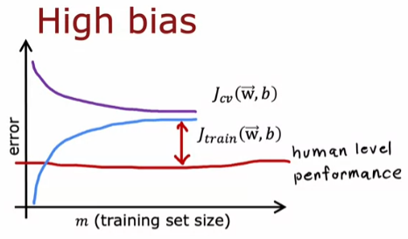
    - If a learning algorithm suffers from high bias, getting more training data will not help much.
  + For high variance:
    - 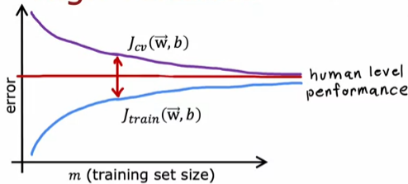
    - If a learning algorithm suffers from high variance, getting more training data is likely to help.
  + Downside of plotting learning curves is that it is computationally expensive to train so many different models.
  + Large enough neural networks always have low bias.
  + Strategy for Neural networks:
    - 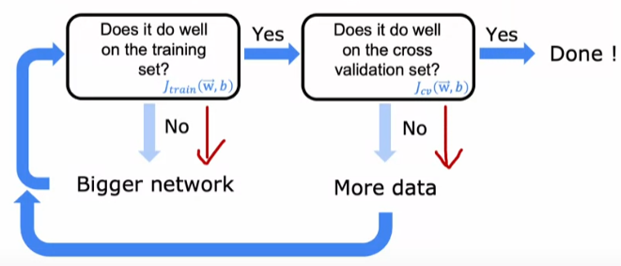
  + Comparison between small and large neural networks:
    - Intuitively, you would think that larger NNs are more prone to overfitting, but that is not the case.
    - 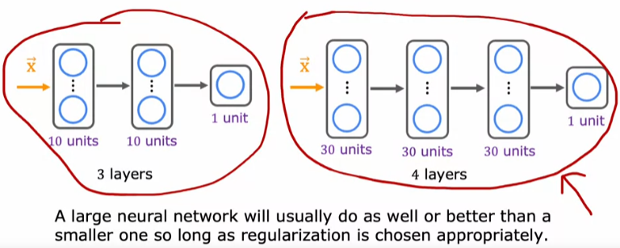
  + Regularization in Tensorflow:
    - 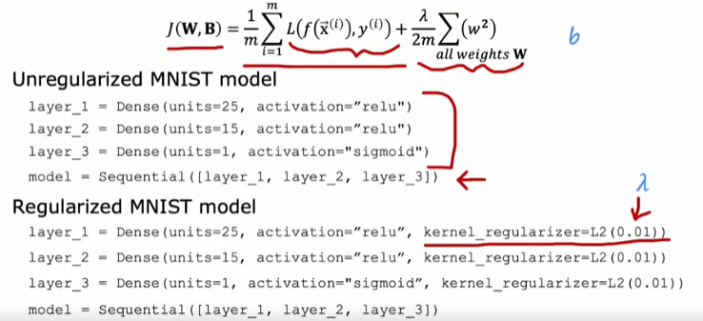

## Development Process

* Steps:
  + 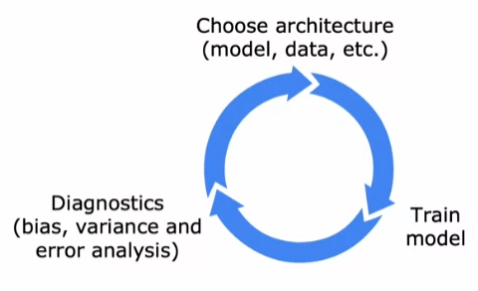
* Error analysis:
  + Manually examine the misclassified examples (or a subset if there are too many) and categorize them based on common traits.
  + The limitation is that it is only easy to do for tasks that humans are good at.
* Adding data:
  + If error analysis has shown that there are certain subsets of the data that the algorithm is doing poorly on, then getting more data of just those types will be sufficient and more efficient way to use your resources.
  + Data augmentation: modifying an existing training example to create a new training example i.e., a new example by distorting an image for handwriting classification.
  + Distortion introduced should be representation of the type of the noise/distortions in the test set.
  + Usually does not help to add purely random/meaningless noise to your data.
  + Data synthesis: using artificial data inputs to create a new training example (usually used in computer vision).
* Transfer learning – using data from a different task.
  + Make a copy of an existing trained NN (with many outputs) and replace the output layer (with less outputs) with your desired outputs.
    - Option 1: only train output layers parameters.
    - Option 2: train all parameters.
  + Training the larger model first is called “supervised pretraining”.
  + The second step of replacing the output layer and retraining is called “fine tuning”.
  + The nice thing about transfer learning is that you might not need to do the pretraining step – you can find existing models on the internet/get someone else to do it first.
  + 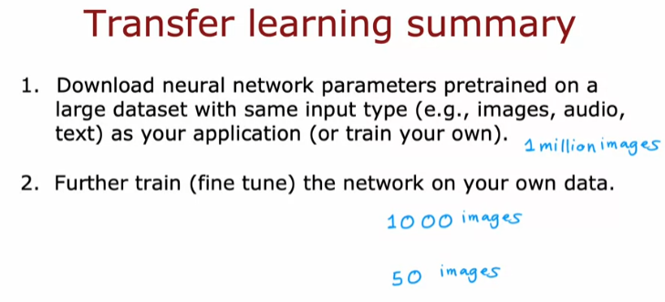
* Full cycle of a ML project:
  + 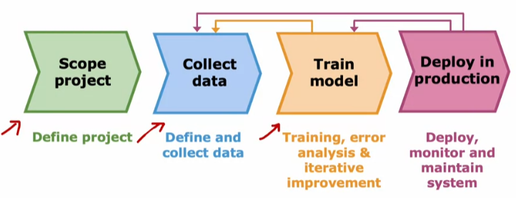
  + Deployment:
    - 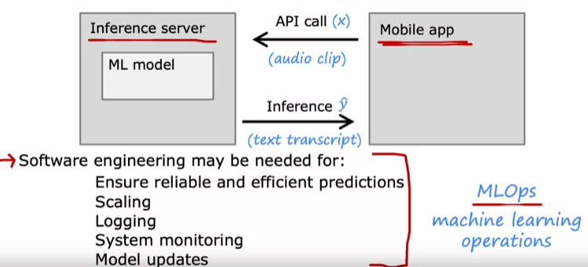

### Fairness, Bias, and Ethics

* Guidelines:
  + Get a diverse team to brainstorm things that might go wrong, with emphasis on possible harm to vulnerable groups.
  + Carry out literature search on standards/guidelines for your industry.
  + Audit systems against possible harm prior to deployment.
  + Develop mitigation plan (if applicable), and after deployment, monitor for possible harm.

## Skewed Datasets

* If your test error is larger than the true positive rate, you can’t really tell if your algorithm is useful or not.
* 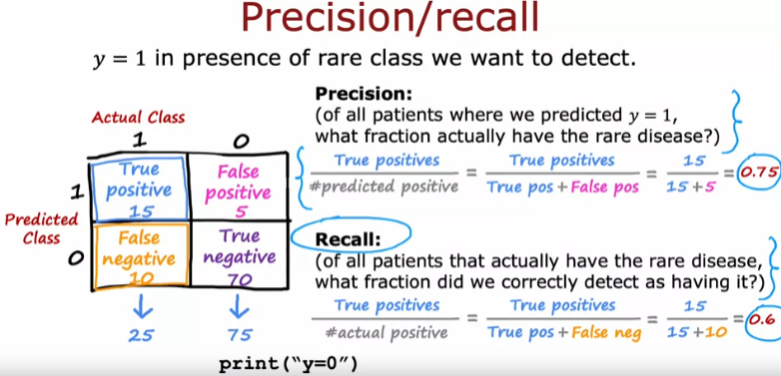
* Using precision/recall will help you tell if your algorithm is useful.
* For a useless algorithm like print(“y=0”), this performs poorly on Recall.
* Values close to 1.0 for both precision/recall is good.
* There is a trade-off between precision and recall.
  + Suppose in Logistic regression, we raise the threshold from 0.5 to 0.7 (predict positive only if very confident):
    - This results in higher precision, lower recall.
  + Suppose we lower the threshold from 0.5 to 0.3 (avoid missing too many cases):
    - This results in lower precision, higher recall.
  + How to compare algorithms with different precision/recall values?
  + 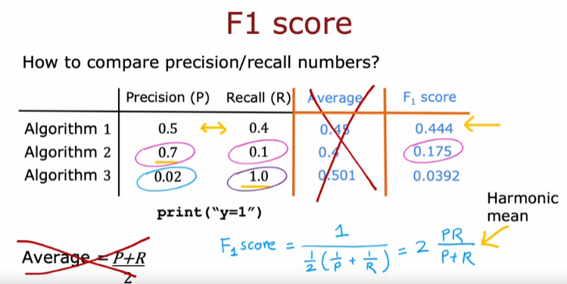
  + This metric emphasizes the lower of the two scores.

# Week 7

## Decision Trees

* Make a series of decisions to classify/predict an input based on how the tree is structured.
* A decision tree consists of root node, decision nodes, and leaf nodes.
* The goal is to pick a decision tree that performs well on training data and generalizes well.
* The learning algorithm tries to iteratively split the examples into their correct groups/classes until all the examples in a group are the same – then put them all in the same leaf node.
* How to choose what feature to split on at each node?
  + Maximize purity (or minimize impurity).
* When do you stop splitting?
  + When a node is 100% one class.
  + When splitting a node will result in the tree exceeding a maximum depth.
  + Improvements in a purity score are below a threshold.
  + Number of examples in a node are below a threshold.

## Decision Tree Learning

* Entropy is a measure of impurity – a function of the fraction of examples that are a certain class i.e., the fraction of examples that are classified as cats.
* 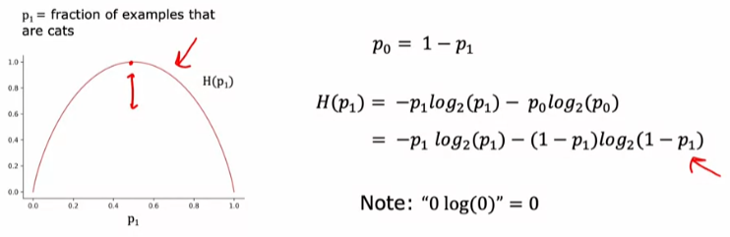
* Deciding which feature to split on at a node will be based on what choice of feature reduces entropy the most.
* The reduction of entropy is called information gain.
* An example of calculating and choosing the highest information gain split:
* 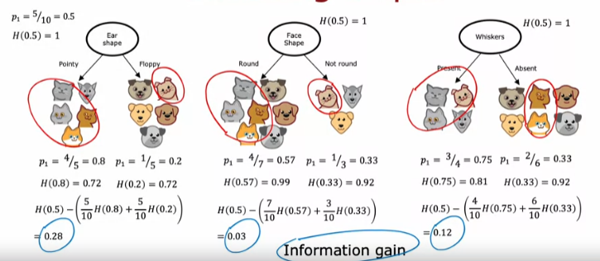
* General formula for information gain:
* 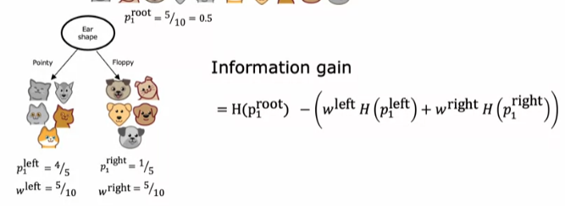
* Algorithm pseudocode (uses recursion):
* 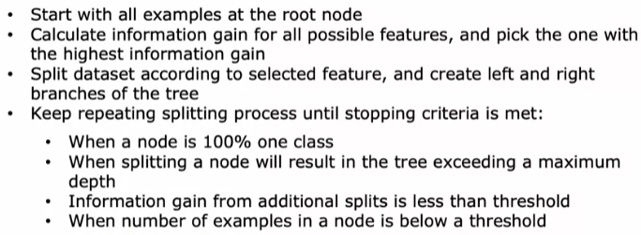
* One hot encoding.
  + If you have features with more than 2 categories, you can use one hot encoding to reduce it to binary classification.
  + Definition: if a categorical feature can take on k values, create k binary features (0 or 1 valued).
* Continuous valued features.
  + Try out different thresholds and pick the one with the highest information gain.
  + Example:
  + 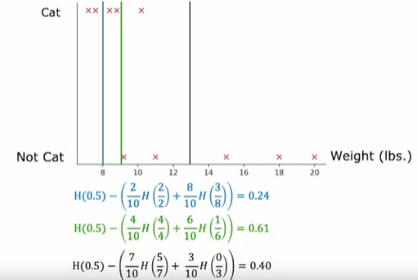
* Regression trees.
  + Predicted output is a continuous value.
  + The output is the average of all target values at the leaf node.
  + Instead of maximizing information gain at each split, when constructing the decision tree, we look to minimize the variance of the continuous target values.
  + Like computing information gain, pick the highest reduction in the weighted variances of the left and right branches (like that done in classification).
  + Example:
  + 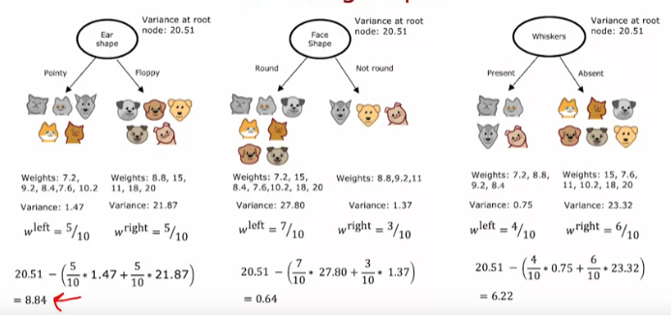

## Tree Ensembles

* Single trees are highly sensitive to small changes of data.
* Changing one training example causes the algorithm to come up with a different split at the root and therefore a totally different tree.
* We often get more accurate results if we train a collection of trees.
* Essentially running the examples through many trees and taking a majority vote of the predictions.
* Bagged Decision Tree:
  + 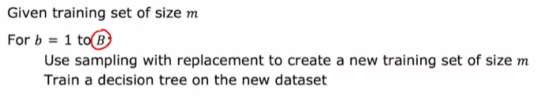
  + Where B is a number can be any number (typically from 64 to 228).
  + Never hurts to have a large B, but up to a certain point, there will be diminishing returns and hurts computation time.
* Random Forest Algorithm:
  + Randomizing the feature choice helps to make the decision trees more different from each other (good thing!).
    - 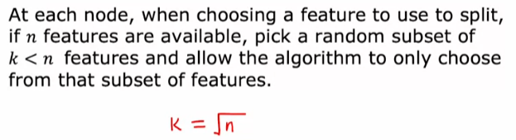
* Boosted Decision Trees.
  + Modification to the random forest algorithm.
  + 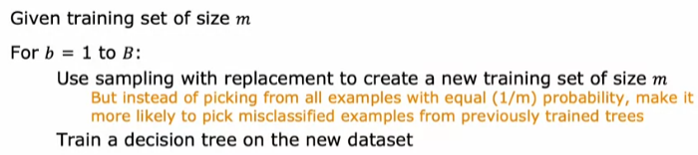
  + Note that the previously trained trees will be run on the original training set (not the one generated through sampling).
  + The most popular today is XGBoost.
    - 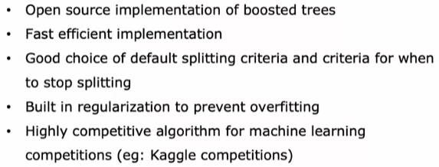
    - Example using classification/regression:
    - 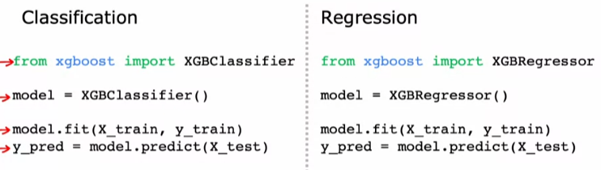
* When to use decision trees?
  + Works well on tabular (structured) data i.e., data looks like a giant spreadsheet.
  + Not recommended for unstructured data (images, audio, text).
  + Tree ensembles are fast to train.
  + Small decision trees may be human interpretable.
  + When to use Neural Networks instead?
    - Works well on all types of data, including tabular (structured) and unstructured data.
    - May be slower than a decision tree.
    - Works with transfer learning (good when you only have a small data set).
    - When building a system of multiple models working together, easier to splice together multiple neural networks.

# Week 8

## Clustering

* Looks at several data points and automatically finds data points that are related or like each other.
* Not given target labels, y – not able to tell algorithm the right answer.
* Rather, we ask the algorithm to find an interesting structure in the data.

## k-means Algorithm

* Step 1 (assign each point to its closest centroid):
  + Take a random guess of k points, which are the centre of k clusters.
  + Cluster centroid: The centre of the cluster.
  + Iterate over each data point and determine the distance to each cluster centroid.
  + Algorithm assigns each data point to each cluster centroid group.
* Step 2 (recompute the centroids):
  + Take the average (centre) of all points in each cluster and move the guess there.
  + Repeat step 1 (from the iterating over each point sub-step).
* When no further changes, the solution has converged, and the algorithm terminates.
* 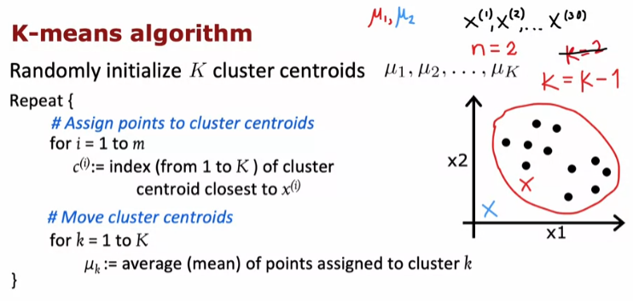
* Edge case: if a cluster is assigned 0 points, it is common to just eliminate that cluster and set k = k – 1.
* Alternatively, you can randomly re-initialize that cluster centroid.
* Optimization objective.
  + Not gradient descent.
  + 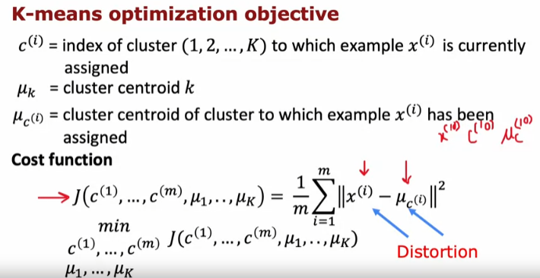
  + The goal of step 1 is to minimize x(i) while holding muc(i) constant.
  + The goal of step 2 is to minimize muc(i) while keeping x(i) constant.
  + 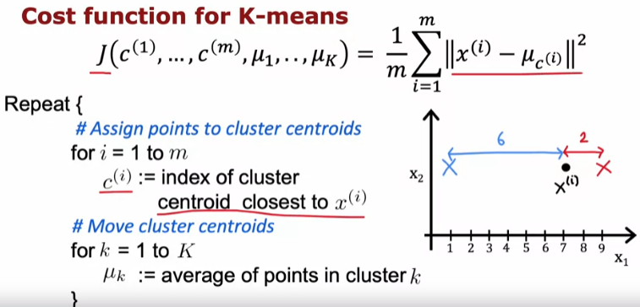
  + On every iteration, the cost function should decrease or stay the same.
  + If it ever goes up, there is a bug in the code because it should decrease at every step.
* Random initialization.
  + How to choose good starting points for cluster centroids?
  + 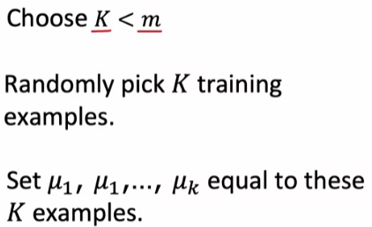
  + You don’t always get the optimal placement with a single random choice, and this can affect the result cluster locations.
  + You can run k-means multiple times with different random starting points and compute the cost J for each – you pick the cost J which is the smallest.
  + 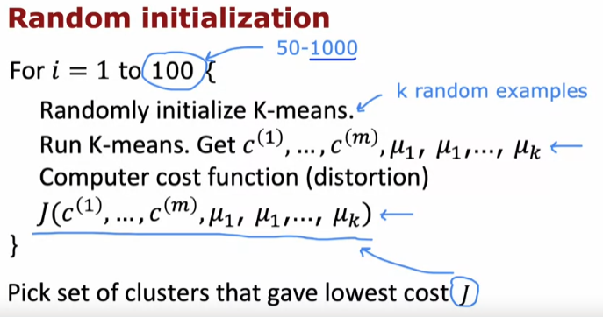
* Choosing the number of clusters, k.
  + Elbow method
    - 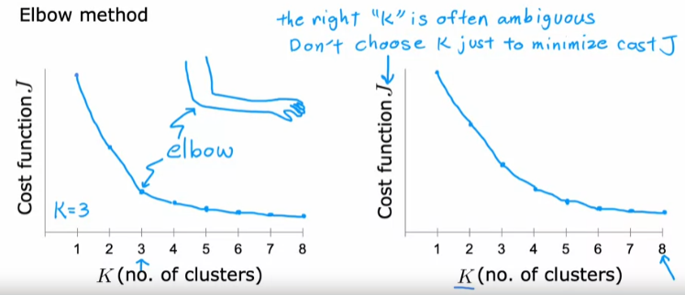
    - Sometimes difficult because there is often no clear “elbow” as in the plot on the right.
  + Evaluate k-means based on how well it performs on the later downstream method.
    - If you need 3 clusters for the downstream application, then choose k=3.

## Anomaly Detection

* Density Estimation.
  + Build a model of the probability that the event you are checking for exists.
  + Compare the new example (xtest) to the model.
  + 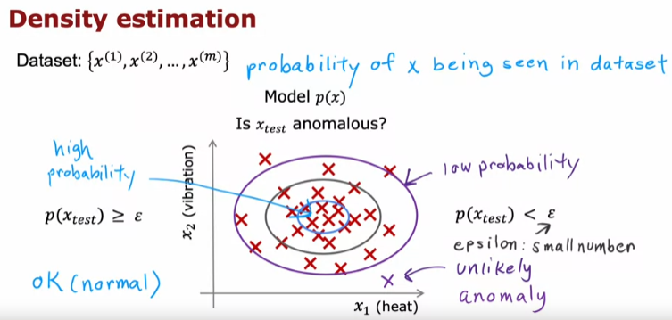
  + Examples of anomaly detection:
  + 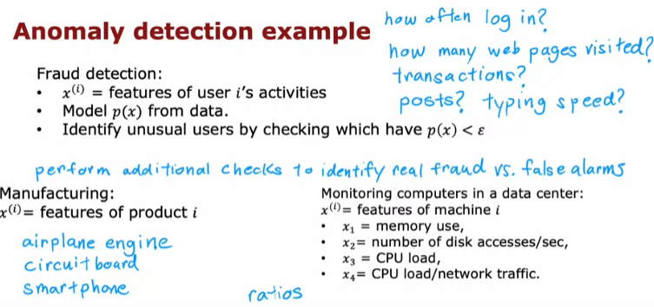
* Gaussian (normal) distribution.
  + 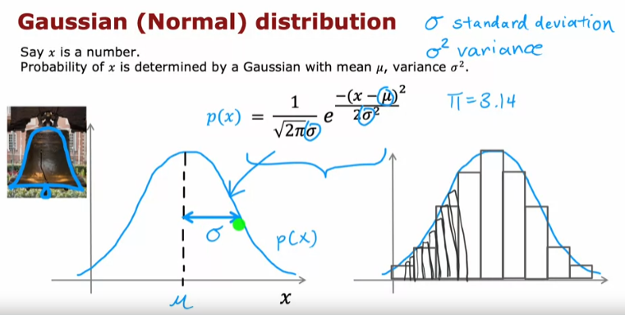
  + Anomaly detection tries to estimate the parameters based on the training set.
  + Formula for computing parameters:
  + 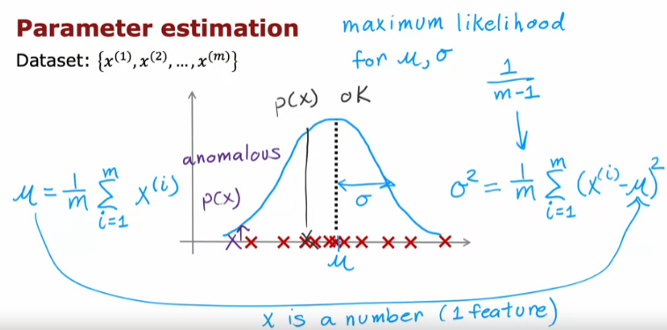
* Algorithm.
  + 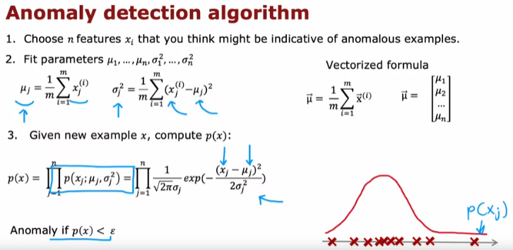
  + Essentially computing the gaussian distribution for each feature and multiplying together the probabilities for a test data point.
* Practical tips.
  + It is helpful to (hopefully) be able to collect some test and cross validation data set with target labels.
  + Train algorithm on training set.
  + Use cross validation set to tune epsilon and xj parameters.
  + Alternative: no test set, just tune epsilon and xj parameters with a larger cross validation set.
    - Downside is after training; you don’t have a test set.
    - But this is useful if you don’t have enough data to create a separate test set.
  + Algorithm evaluation:
  + 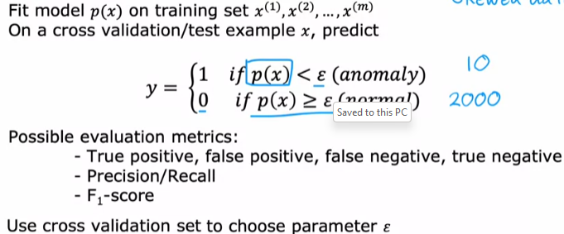
* Anomaly Detection vs. Supervised Learning.
  + 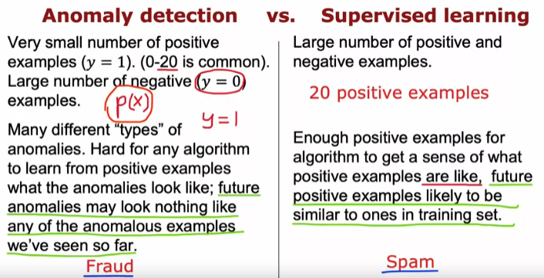
  + Different use cases:
  + 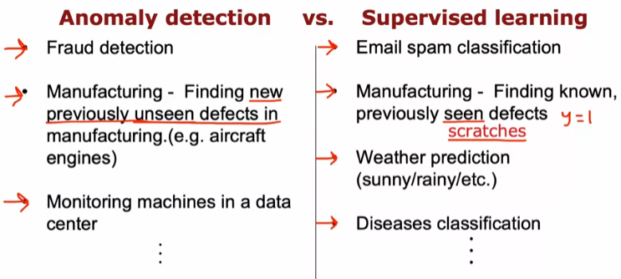
* Choosing the right features to use.
  + For unsupervised learning, it is harder for the algorithm to figure out which features to use and which to ignore, since it has no target label, y provided.
  + Carefully choosing features is more important for unsupervised learning than supervised learning algorithms.
  + Change your features to be more “gaussian” – transform skewed data sets (maybe by taking the log(x) or log(x+constant) or sqrt(x) of the x-axis values).
  + Error analysis for anomaly detection.
    - p(x) is comparable for both normal and anomalous examples.
    - Can try to add new features which may help to separate out anomalous values from normal ones.
    - 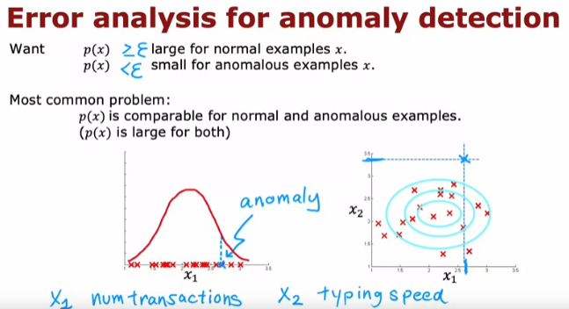
    - An example of using new features for a data centre monitoring.
    - 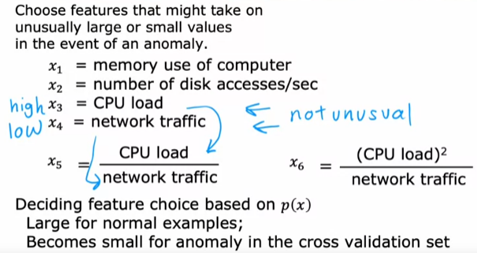

# Week 9

## Collaborative Filtering

* Terminology:
  + nu: number of users.
  + nm: number of items (to recommend to the users).
  + r(i,j): value of 1 if user j has rated item i.
  + y(i,j): rating given by user j to item I (defined only if r(i,j)=1).
  + n: number of features for each item.
  + x(i): features for item i (stored as a vector of features for that item).
* 
* w(j) and b(j) belong to a particular user.
* This is exactly like linear regression.
* Cost function:
  + 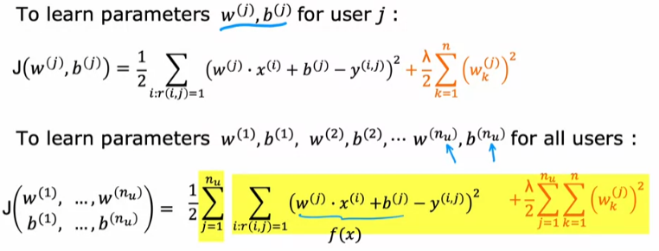
  + Like linear regression except without dividing by the m term.
  + Can use gradient descent or some other algorithm to minimize the cost function.
* What if you don’t have values for features (x(i))?
  + Assuming you have w, b parameters for each user:
  + 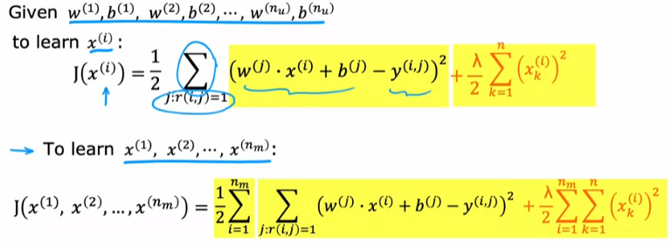
  + This helps to get features for each item.
* Collaborative Filtering.
  + Add the two cost functions above together to obtain:
  + 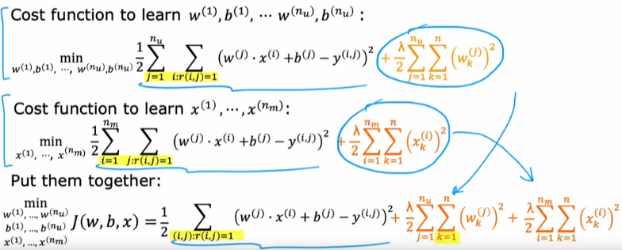
  + Use gradient descent (as in linear regression) to minimize the cost function.
  + 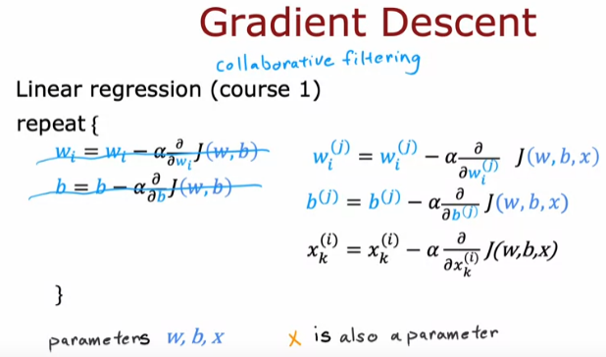
* Binary labels.
  + Example applications:
    - 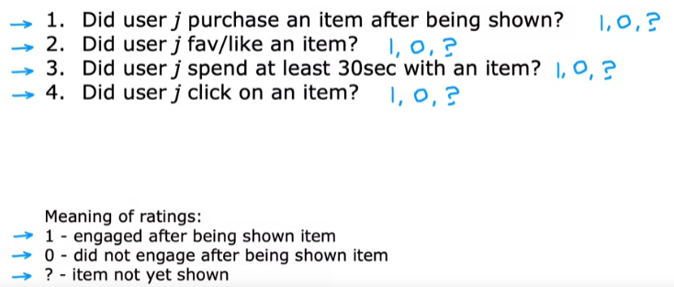
  + From regression to binary classification:
    - 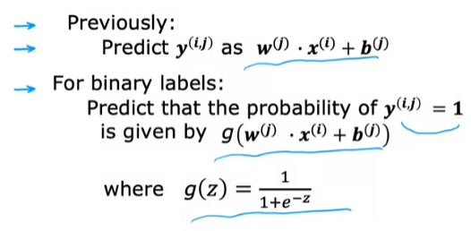
  + Cost function for binary application.
  + 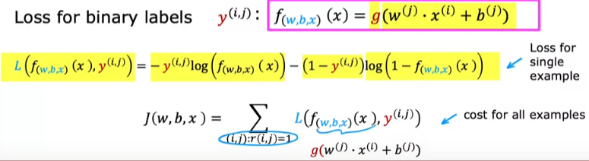

### Recommender Systems Implementation Details

* As in the case for linear regression, feature normalization can help the algorithm perform better.
* Mean normalization:
  + Subtract each item’s average rating from each of its score given to it by a user.
  + This helps the algorithm to perform better.
  + Also, when a new user with parameters **w**, b is set to 0, it predicts the rating of a movie will be the mean.
  + 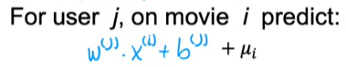
* Tensorflow implementation of collaborative filtering.
  + Example of a training loop:
  + 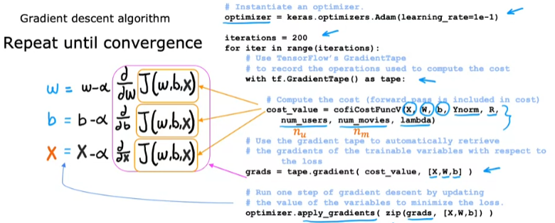
* Finding related items.
  + 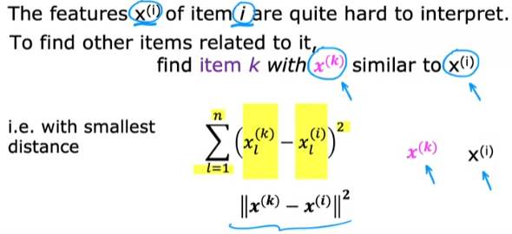
* Limitations of collaborative filtering:
* 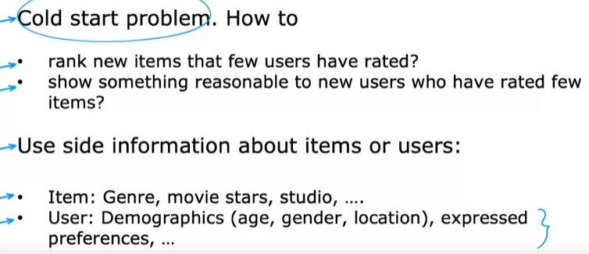

## Content-based Filtering

* Difference with collaborative filtering:
* 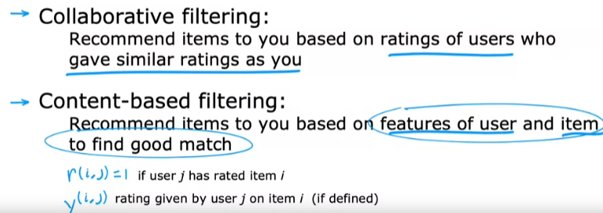
* Algorithm learns to match users to movies.
* Deep learning for content-based filtering.
  + Use two separate neural networks, one for user, one for the item (movie).
  + Dot product both the vector outputs to obtain vu (dot product) vm.
  + The output dimensions of both networks must be the same.
  + 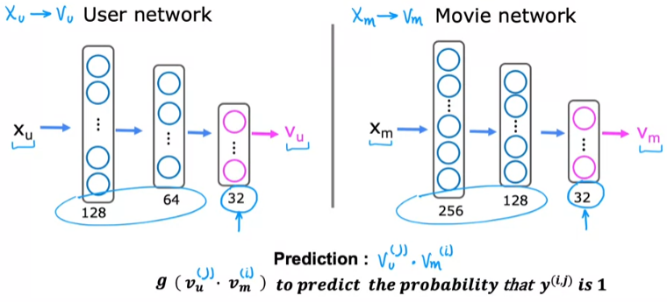
  + The cost function can be used with an algorithm like gradient descent to tune the parameters of the model.
  + 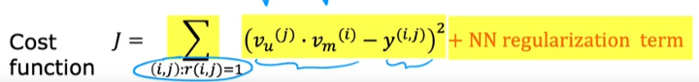
  + To find items (movies) that are similar to each other, compute the squared difference of two item (movie) vectors, vm(k).
  + Note that this difference can be computed ahead of time (say overnight) or while the user is not using the service.
* Large catalogues.
  + If you have many products, re-running the computation for many users becomes computationally infeasible.
  + Many large-scale recommender systems are implemented as two steps: Retrieval & Ranking.
    - The retrieval step (relatively fast):
    - 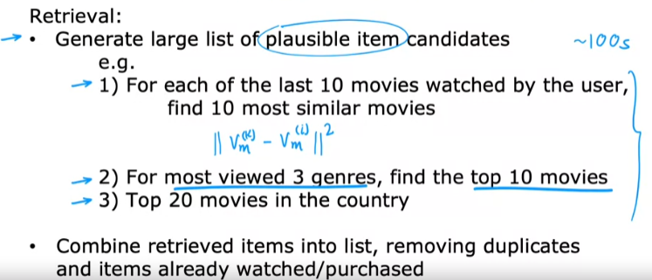
    - The ranking step:
    - 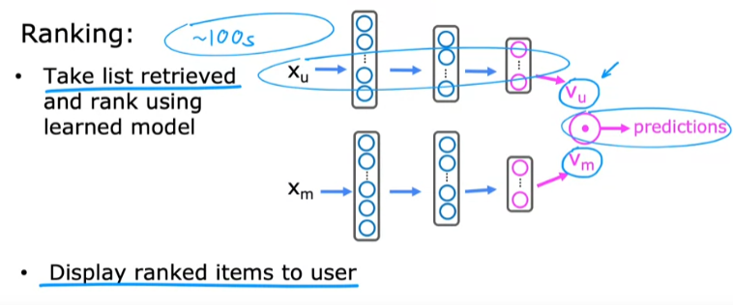
    - If you have vm computed ahead of time, all you need to do is compute vu which shouldn’t take too long.
  + Retrieving more items results in better performance, but slower recommendations.
  + To analyse/optimize trade-offs, carry out offline experiments to see if retrieving additional items are beneficial (i.e., p(y(i,j))=1 of items displayed to user are higher).
* Ethical considerations.
  + Two different use cases using the same system.
  + 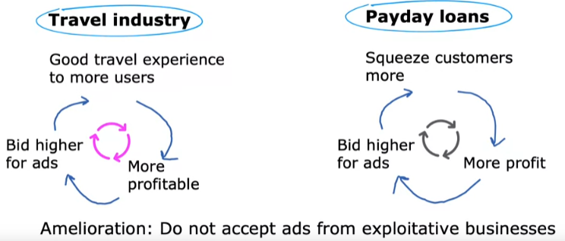
  + Other problematic cases:
    - 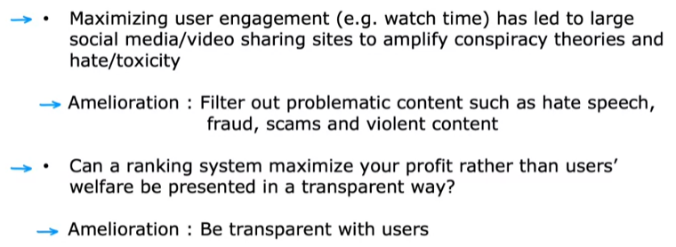
* Tensorflow implementation.
  + 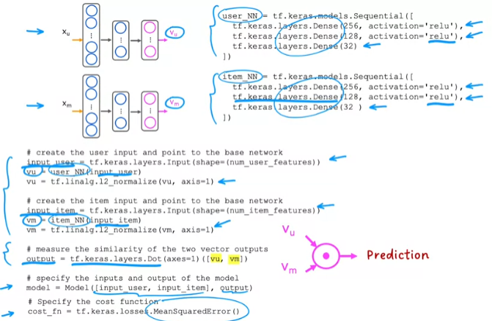

# Week 10

## Reinforcement Learning

* Don’t tell the algorithm how to do it, just reward positive behaviour and give negative reward for bad behaviour.
* Applications:
  + Controlling robots.
  + Factory optimization.
  + Financial trading.
  + Playing games.
* In reinforcement learning, every state is represented by a 4-tuple: (current state, action, reward at the current state, next state).
* To encourage faster reward gains, the Return rewards actions which lead to rewards that happen sooner.
* 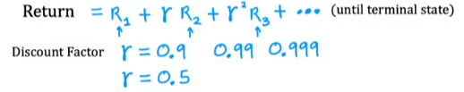
* The Return depends on the actions you take, and which state you start in.
* 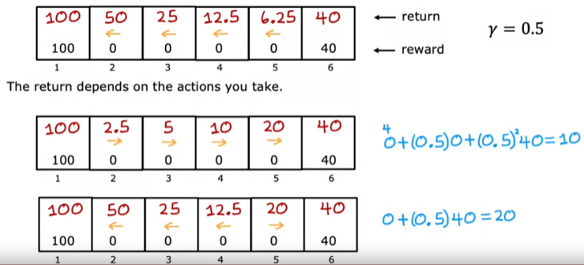
* Reinforcement learning aims find a policy which takes a state and outputs an action – while maximizing reward.
  + Find a policy pi that tells you what action to take in every state to maximize the return.
* A policy is a function pi(s)=a mapping from states to actions, that tells you what action a to take in each state s.
* Examples of using reinforcement learning:
* 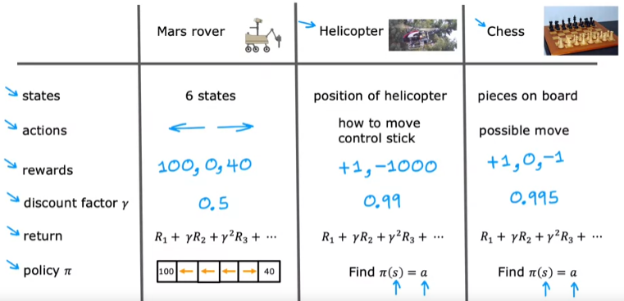
* Markov Decision Process (MDP)
  + The future only depends on the current state.
  + 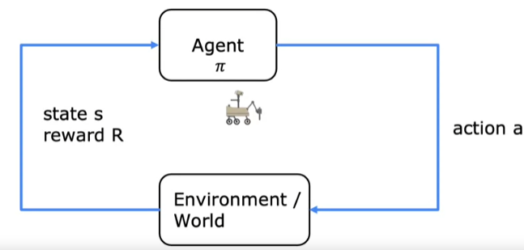

### State-Action Value Function

* Q(s,a) is the Return you get if you start in state s, take action a (once), and behave optimally after that.
* The best possible Return from state s is the maximum Q over all possible actions.
* The optimal value of Q is also known as Q* in some literature.
* Bellman Equation
  + 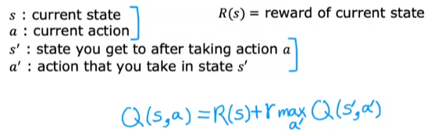
  + Recursively defined.
* Random (stochastic) environment.
  + What if there was a non-zero probability that the robot would take another action rather than the optimal one?
  + This results in a modified version of the Bellman equation, which maximizes the expected average Return over multiple runs of the algorithm.
  + 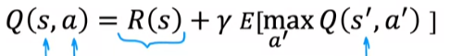

## Continuous State Spaces

* States could be continuous values such as orientation (in degrees) or position (in meters).
* Complex applications like autonomous vehicles could have a state represented by a vector of continuous values (like speed).
* The Lunar Lander Problem:
* 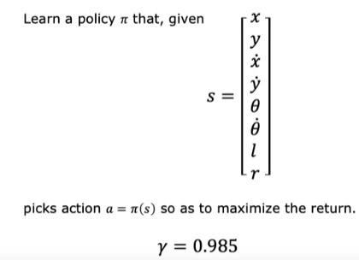
* Where the symbols are the x-position, y-position, x-speed, y-speed, tilt, angular velocity, is the left leg on ground, is the right leg on the ground.
* Learning algorithm:
  + Uses a neural network.
  + 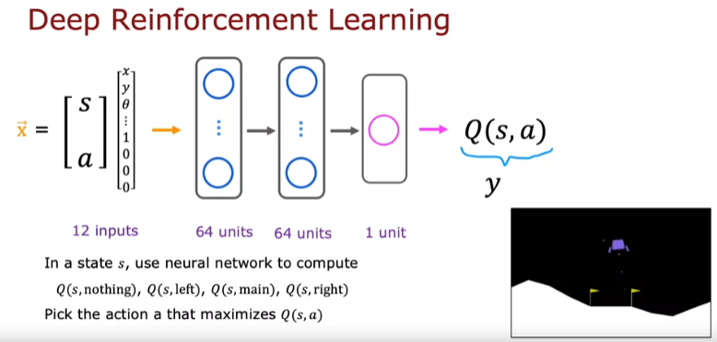
  + How do we generate training examples for the neural networks?
    - We can use the Bellman Equation.
    - 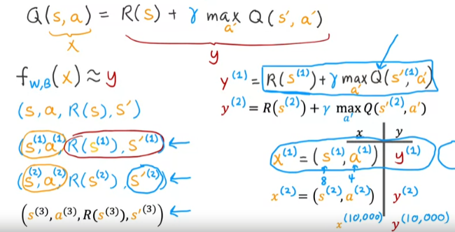
  + Full algorithm:
    - 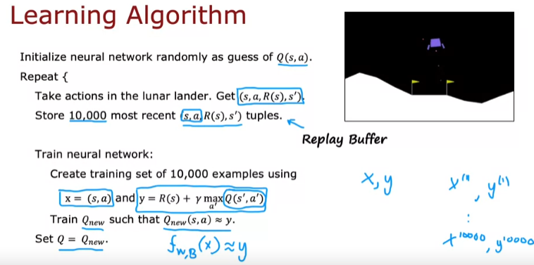
    - Sometimes called a DQN algorithm (Deep Q-Network), where Q is the Q function.
* Making DQN more efficient:
  + Improved NN architecture.
    - Rather than carry out inference for each of the 4 (or n) actions available, output the Q values for all four (or n) states in one inference.
    - 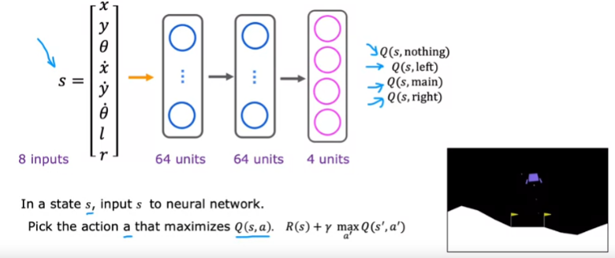
  + Epsilon-greedy policy.
    - How can we take a better action in each iteration of the algorithm while it is still learning (originally guessed value of Q)?
    - Pick actions with a certain probability that maximizes Q.
    - This helps to overcome any preconceptions the algorithm might have because of a randomly initialized Q value.
    - 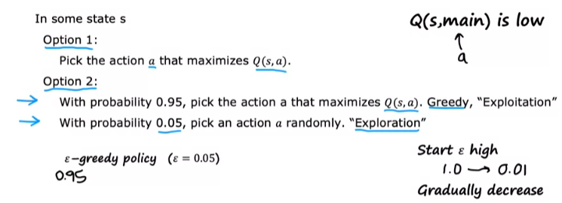
  + Mini-batching.
    - Can be applied to supervised algorithms as well.
    - Don’t use all training examples on every step of gradient descent if you have an excessive amount of training examples.
    - Makes each iteration compute faster and more efficient.
    - Divide the training examples into groups of batches to be used at each iteration (or alternatively, pick a few random examples at each iteration).
    - There is a trade-off with the path taken, but it tends to be faster overall due to the smaller number of training examples.
    - 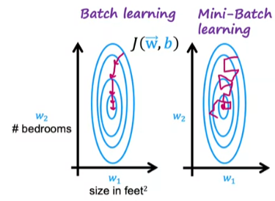
    - Lunar Lander example:
    - 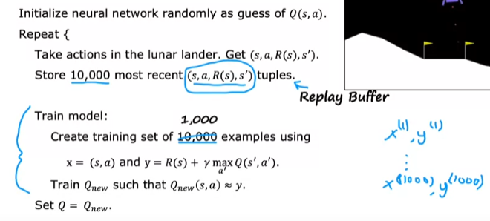
  + Soft updates.
    - Helps reinforcement learning application converge to a solution faster.
    - In the Set Q = Qnew step of the algorithm.
    - 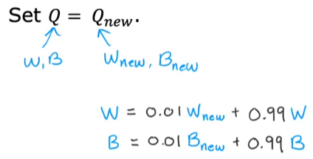
* State of Reinforcement Learning.
  + Limitations:
    - Much easier to get to work in a simulation than a real robot.
    - Far fewer applications than supervised and unsupervised learning.
    - Exciting research direction with potential for future applications.